Speech of the 11th of June

My deep gratitude to His Excellency the Consul General of Japan Mr Miyagawa, as well as to all the persons who were kind enough to back this decision to honor me with “the Order of the Rising Sun, Gold and Silver Rays” decoration.
I have two reactions towards this great honor: the first, naturally, is a reaction of gratitude and great joy. But this reaction is sobered by the conviction that it will take me many years to be worthy of such an honor.
The road to follow was shown to me by my masters who, whether deceased or still alive but too far to be physically with me today are represented here in pictures. Shimizu Takaji Sensei, Kuroda Ichitarô Sensei, Nishioka Tsuneo Sensei, Donn F. Draeger Sensei, Kaminoda Tsunemori Sensei, Saitô Isoji Sensei. (I’ll introduce them showing their pictures on a big sheet). At the bottom, my father, deceased in 1971, who has been a master through his good example.
These masters taught me the attitude I should have in a Dôjô. They showed me that martial disciplines were a path of peace, not war.
What is left for me to do today is to implement these teachings in my daily life, outside the Dôjô. This decoration is an urgent call for this work which is still to be completed.
Accepting this great honor today is a promise to all my masters, and my father, as well as to all the people here today, to try, again and again, to respect the Confucian Five Conditions stipulated in the scrolls I received from my Jôdô Masters: Benevolence, Justice, Politeness, Knowledge and, while being careful to practise the last four at the light of the first one.
I also wish to associate to this decoration all the people who helped me on the way of life and Budô:
My mother, Marie-Cécile, the best mother (as I have only one),
Anne-Laure Luisoni, the woman with whom I live, and whose advices I often listen
Michel Novovitch, my Jûdô Sensei and good friend,
Malcolm Tiki Shewan, with whom I share the best of Japanese culture since more than 30 years,
Germain Steiner, a faithful friend I met in Jûdô, 40 years ago
Christian Vuissa, with whom I taught Jûdô for some ten years.

As well as my students without whom I would not be what I am today:
Georges Kraus, the eldest one,
Michel Ducret and Michel Colliard, both my most ancient students,
Sergio Dieci, my second in Jôdô
Jean-Louis Martin and Dominique Falquet, my seconds in Iaidô and Kenjutsu,
And, finally, Marie-Claude Hefti, President of the SDK, the club that made it possible for me to train and teach for more than 42 years.
I am happy that this great honor will be shared by all the people here tonight, and, in particular, by my children: Isamu, my eldest child, Naomi, my eldest daughter, Sébastien, my second son, Marion, my second daughter, and Yanoé, my youngest, without forgetting my first grand-child Jun Kun.
With my Masters, with all the people here tonight, as well as their wives and companions, I thank the Country of Japan and the Japanese Government. I solemnly promise to continue to promote this wonderful Japanese culture in Occident as long as I live.
Thank you very much for your attention.
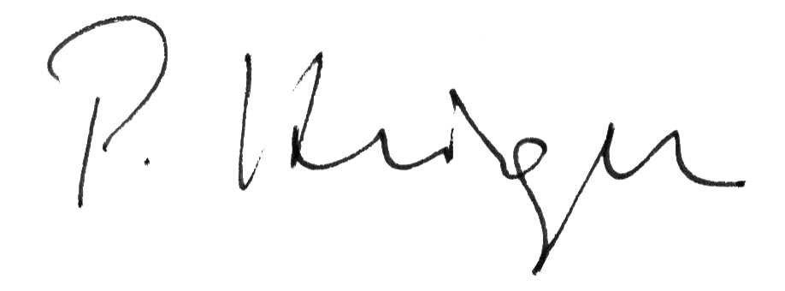Pascal Krieger, Geneva, 11 June 2008

